1. Write a C program to simulate a Deterministic Finite Automata (DFA) for the given
language representing strings that start with a and end with a
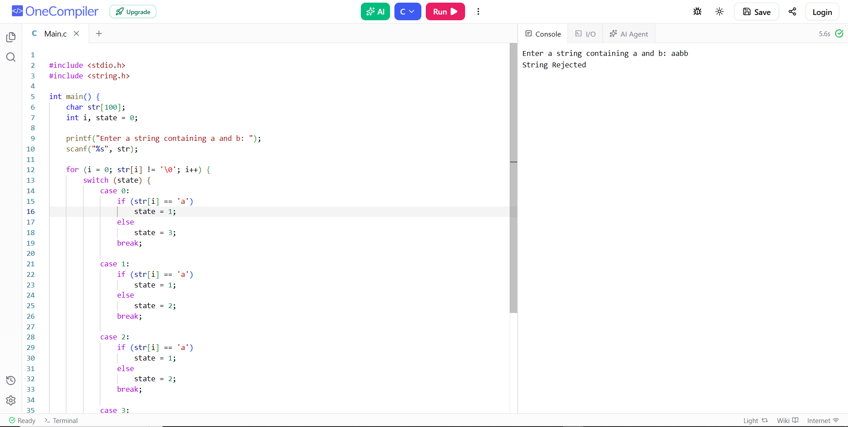
2. Write a C program to simulate a Deterministic Finite Automata (DFA) for the given
language representing strings that start with 0 and end with 1
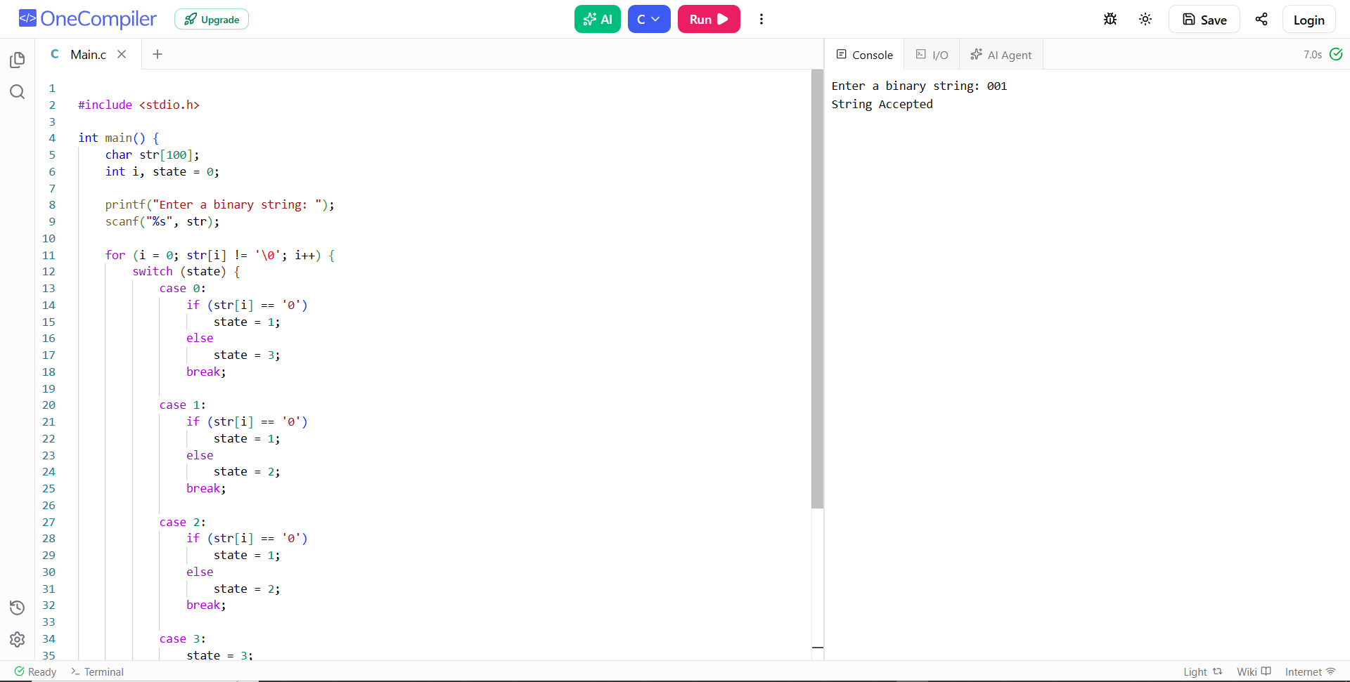
3. Write a C program to check whether a given string belongs to the language defined
by a Context Free Grammar (CFG)
S → 0A1 A → 0A | 1A | ε
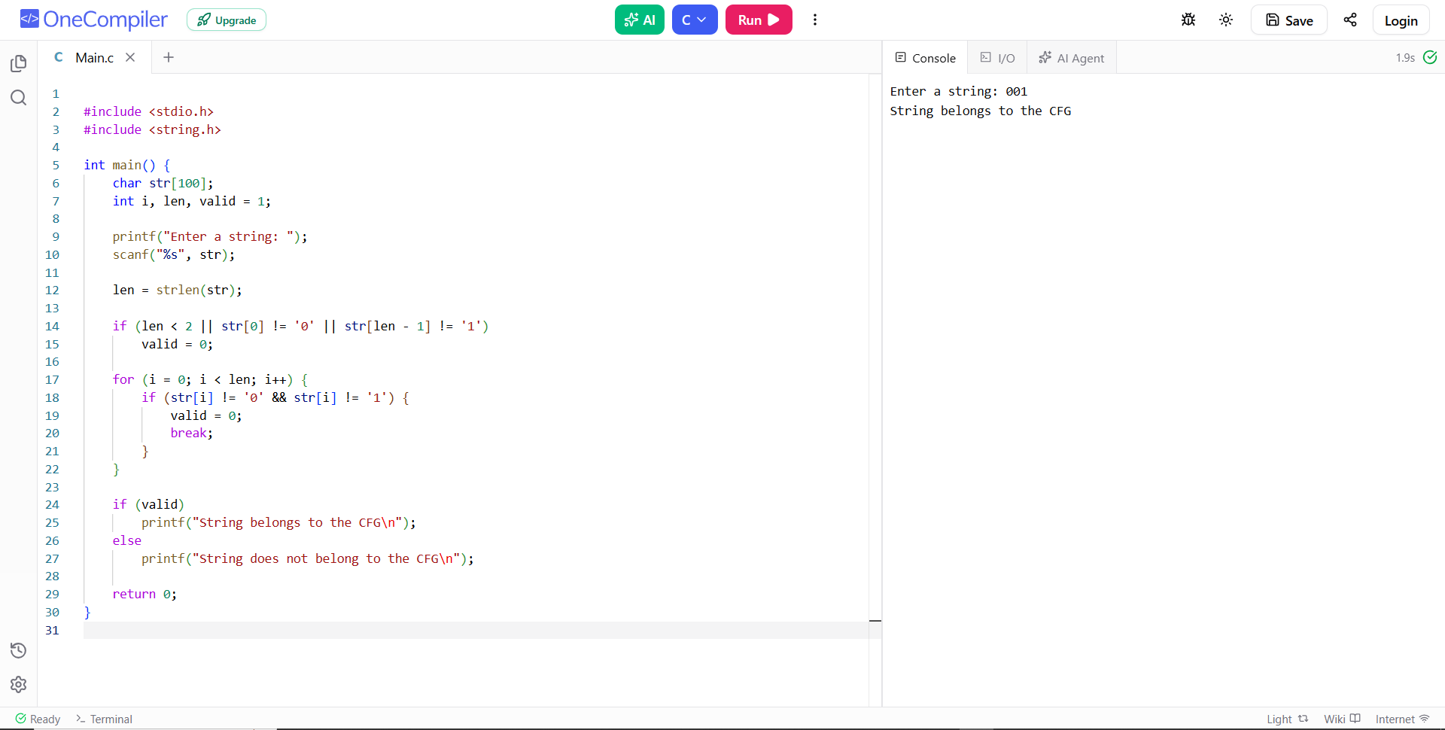
4. Write a C program to check whether a given string belongs to the language defined
by a Context Free Grammar (CFG)
S → 0S0 | 1S1 | 0 | 1 | ε
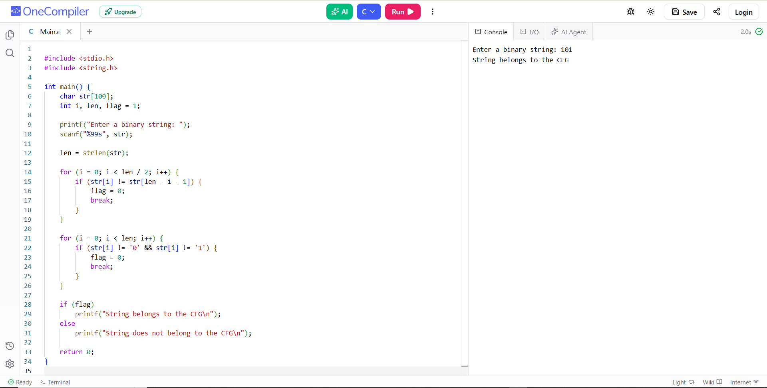
5. Write a C program to check whether a given string belongs to the language defined
by a Context Free Grammar (CFG)
S → 0S0 | A A → 1A | ε
